DIMITRIOS THEMISTOKLAKOS
Κ.ΠΑΛΑΜΑ 18, TK 54630, ΤEL-0030 2310 536593
FAX-0030 2310 533403 , www.stefagomma.com
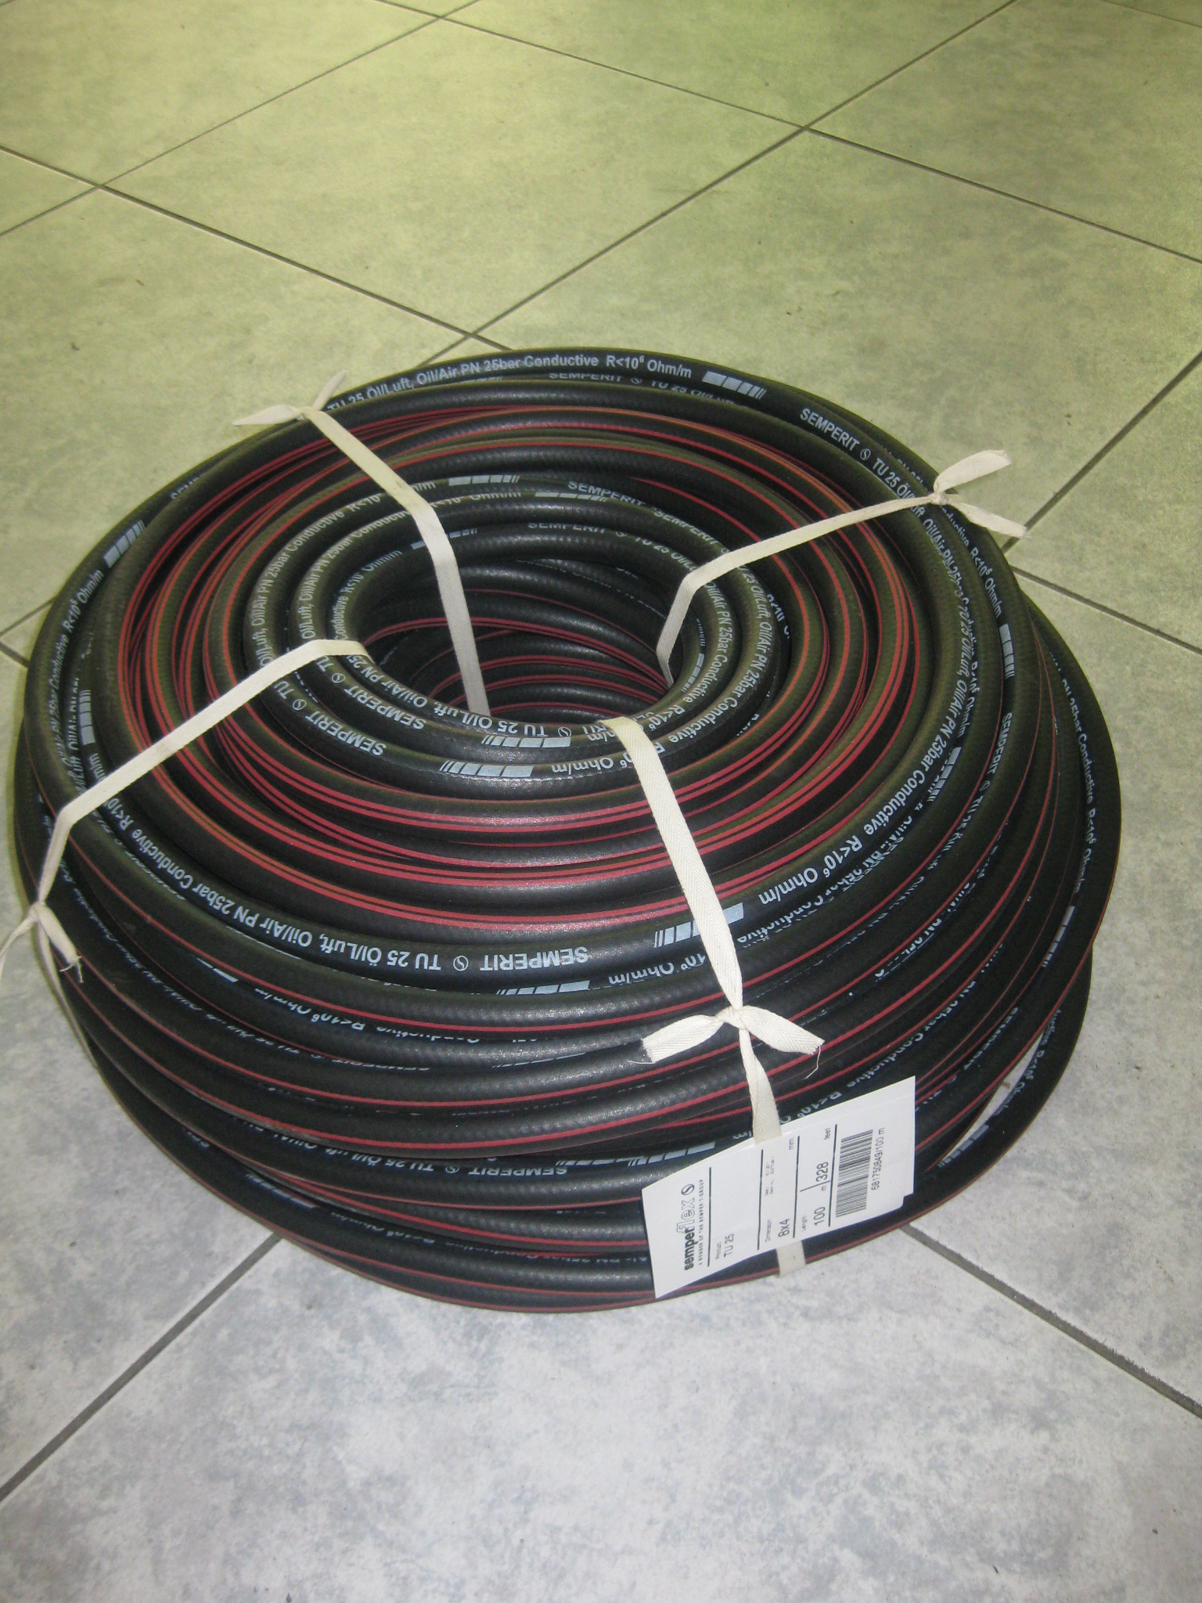
OIL-PETROLEUM HOSE
INDUSTRIAL HOSE BLACK
RESISTANCE 25 BAR
TEMPERATURE : -40 TO +80Oc
SUITABLE FOR OIL-DIESEL-GASOLINE-AIR
SAFETY FACTOR : 3,15:1

BLACK HOSE CODE | DESCRIPTION
3006079020 | OIL-PETROLEUM HOSE 7,9 MM. 25 BAR (T2) SEMP.
681750649 | OIL-PETROLEUM HOSE 6Χ4 MM 25 BAR (T2) SEMP.
681751040 | OIL-PETROLEUM HOSE 10Χ4 MM 25 BAR (T2) SEMP.
681751340 | OIL-PETROLEUM HOSE 13X4 MM 25 BAR (Τ2) SEMP.
681751645 | OIL-PETROLEUM HOSE 16X4,5 MM 25 BAR (T2) SEMP.
681751950 | OIL-PETROLEUM HOSE 19Χ5 MM 25 BAR (T2) SEMP.
681732246 | OIL-PETROLEUM HOSE 22Χ4,5 MM 25 BAR (T2) SEMP.
681752555 | OIL-PETROLEUM HOSE 25X5,5 MM 25 BAR (Τ2) SEMP.

